ReadMe - Assessment

TLIKNOWLODGE

In this assessment I have implemented the program which will calculate net payable amount for the bill provided. BillImpl class has two input methods – 1. Input method which interacts with user to get the bill details and 2. Input can be used to pass the required data.

In my test cases , I have added test cases for both input methods.

To test unit test cases – please run as Junit test as shown below using following test class–

BillImplTest

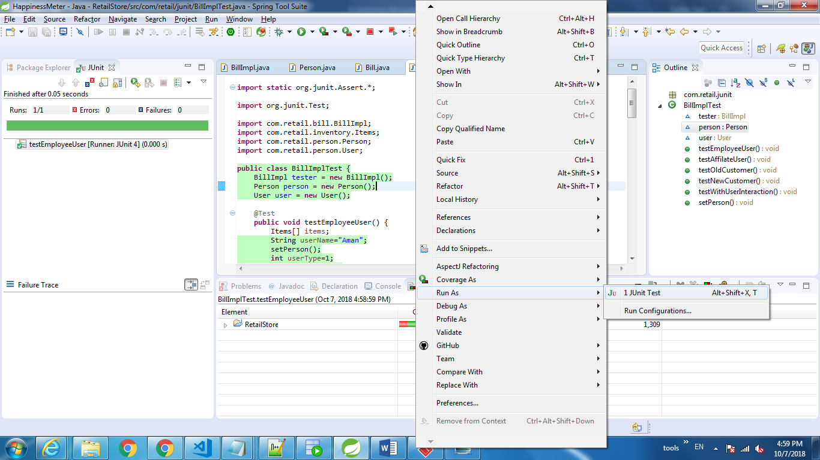

To Run Program – Please use main method in BillImpl class

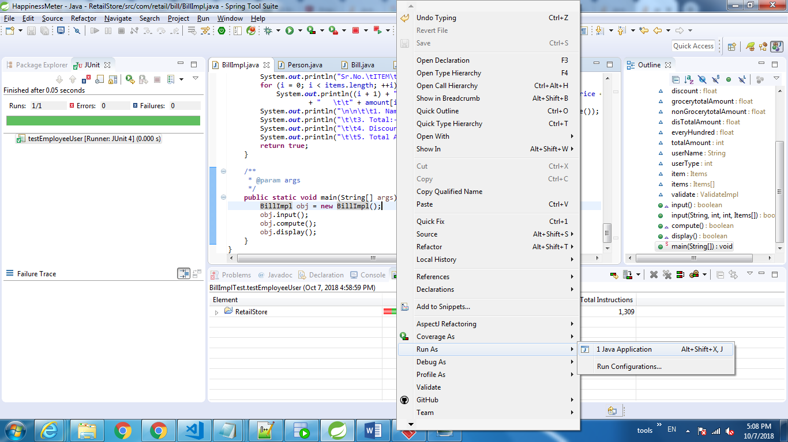

UML Class Diagram:

This assessment has 5 classes and 2 interfaces. User class is derived from person class (inheritance) and BillImpl implements Bill interface(abstraction). Items class has relationship with User class and associated with BillImpl class. Sorry I have used visual Paradigm evaluation version.

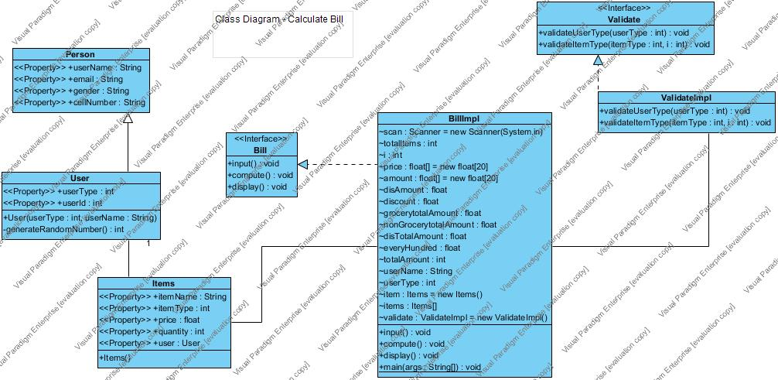

Test Coverage – I have achieved 94% of the coverage . To test coverage please install ECLEmma Java Code coverage.

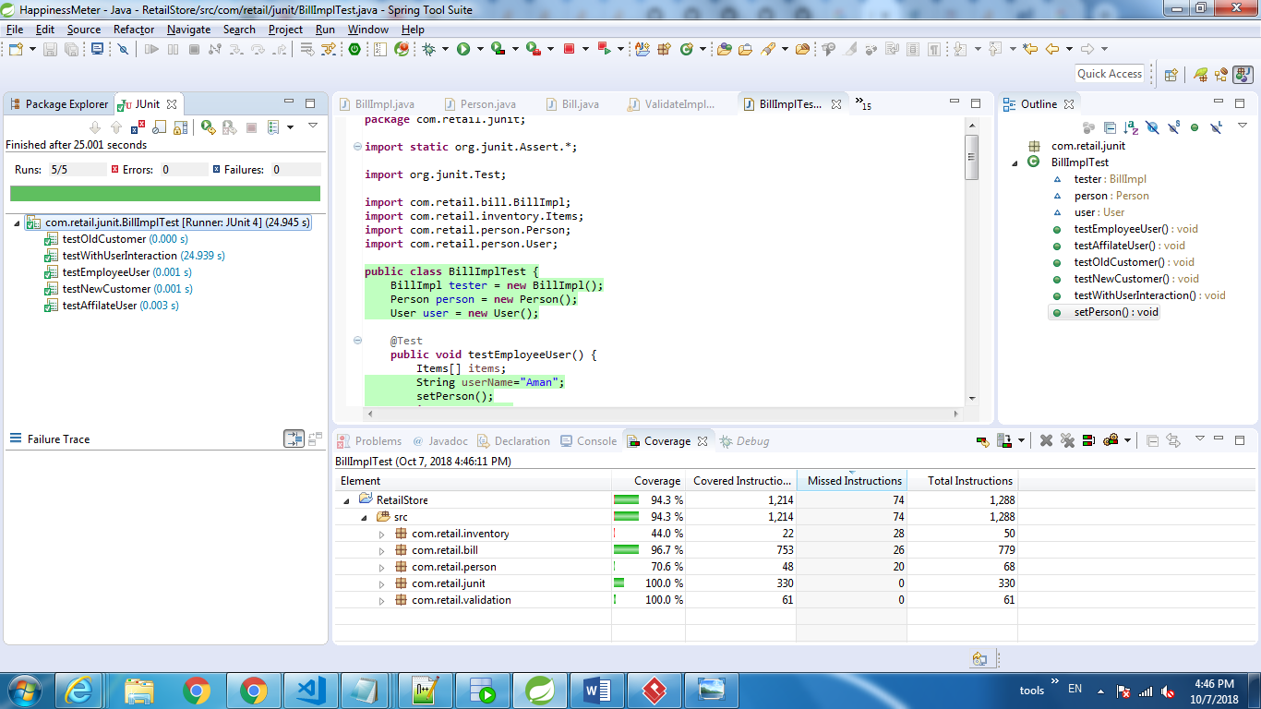

ECL Emma

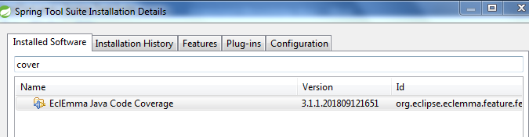

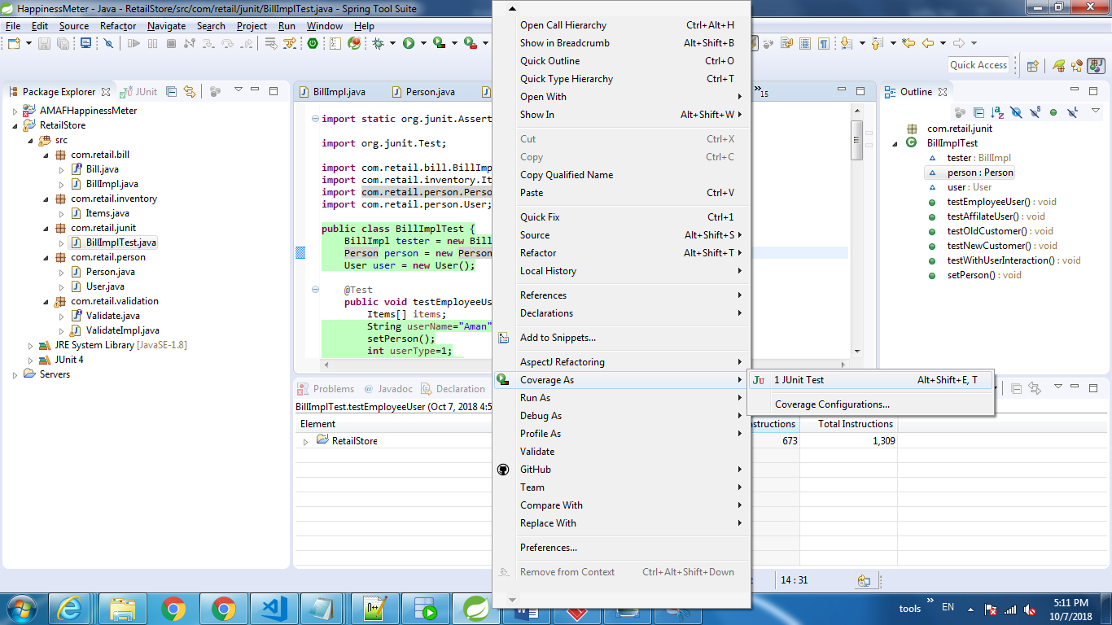

Thank You!!

Mohammad Mustufa Shiddique

+971588837746(UAE)

+919900723942(India)